**SQL and General Databases**

1. What is a Primary Key (PK)?

* A special relational database table column (or combination of columns) used to uniquely identify a table record

1. What is a Foreign Key (FK)?

* A column in one table that points to unique values in another (usually the primary key)

1. What is a unique key?

<https://www.tutorialspoint.com/primary-key-vs-unique-key>

1. Can a table have multiple primary keys?

No

1. Can a table have multiple unique keys?

Yes

1. What is a concatenated/composite key?

Concatenated Primary Key

* Also known as composite primary key is a combination of two or more column values used to define a key in a table.

1. If you have two tables Employee (columns: id and name) and Department (columns: id and name), how would you use the primary and foreign keys to join them?

* One department has multiple employees, so a foreign key would be added to Employee to assign the department id, which matches an id in the Department table.

1. Write a query that returns the third highest salary from a table.

SELECT column FROM table ORDER BY column DESC LIMIT 2,1;

1. Why would you want to use PostgreSQL for a store project?

* PostgreSQL is a powerful, open-source object-relational database system that uses and extends the SQL language combined with many features that safely store and scale the most complicated data workloads
* A very large store would benefit from PostgreSQL

1. Standard Query Language (SQL)?

* Used to perform database operations
* Database Operations:

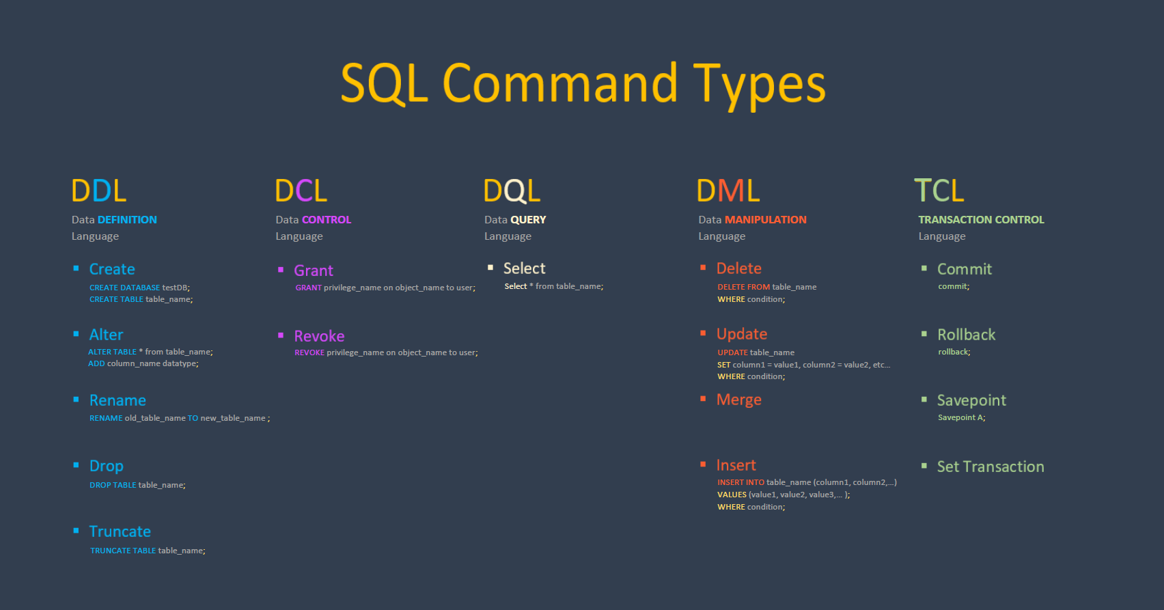

1. SQL Index

* An index contains keys built from one or more columns in the table or view.
* These keys are stored in a structure (B-tree) that enables SQL Server to find the row or rows associated with the key values quickly and efficiently.
* SQL Server documentation uses the term B-tree generally in reference to indexes.
  + 1. The key based on one or more column
    2. Pointer to a table, used to speed up data retrieval

1. Types of SQL Procedures?

* **IN**
  + This is the Default Parameter, which always receives the values from the calling program.
  + It is a READ-ONLY VARIABLE inside the subprograms and its value CANNOT BE CHANGED inside the subprogram
* **OUT**
  + Used for getting output from the subprograms
* **IN OUT**
  + This parameter is used for both giving input and for getting output from the subprograms

1. What are Functions in SQL?

* A function is a set of SQL statements that perform a specific task
  + Functions foster code reusability.
* If you have to repeatedly write large SQL scripts to perform the same task, you can create a function that performs that task.
* Next time instead of rewriting the SQL, you can simply call that function.

1. What are triggers in SQL?

* A trigger is a special type of stored procedure that automatically runs when an event occurs in the database server.
* DML triggers run when a user tries to modify data through a data manipulation language (DML) event.
* DML events are
  + INSERT
  + UPDATE
  + DELETE statements on a table or view.

1. SQL FUNCTIONS

* AVG() - Returns the average value
* COUNT() - Returns the number of rows
* FIRST() - Returns the first value
* LAST() - Returns the last value
* MAX() - Returns the largest value
* MIN() - Returns the smallest value
* SUM() - Returns the sum

1. What is the database designing technique called?

Normalization

1. Types of NORMALIZATION

* 1NF
  + Only single values permitted (no repeated groups)
* 2NF
  + Must be 1NF and the primary key be a single attribute
  + If the relation has a composite primary key (PK), then each non-key attribute must be fully dependent on the entire primary key and NOT on a subset of the primary key (i.e., there must be no partial dependency or augmentation)
* 3NF
  + Must be in 2NF plus all transitive properties removed. That is, no non-key attribute should be dependent on another
* 4NF
  + No multivalued dependencies other than candidate key
* BCNF (Boyce-Codd Normal Form)
  + There shouldn’t be a way to create more than one candidate key. Removing this puts it in BCNF.

1. SQL Views

* Virtual tables based on the result-set of an SQL statement

1. SQL Joins

* Combines rows from two or more tables based on a commonality

1. Types of SQL Joins?

CROSS Joins

* used to generate a paired combination of each row of the first table with each row of the second table.
* This join type is also known as cartesian join

EQUI Join

* combines tables based on matching values in specified columns

LEFT Join

* returns all records from LEFT table and matched records from RIGHT

RIGHT Join

* returns all records from RIGHT table and matched records from left-to-right

FULL/OUTER Join

* returns all records from BOTH tables (combination of left join and right join)

SELF Join

* joins the table with itself to allow for the comparison of rows

NULL Join

* Null values in tables or views being joined never match each other
* Since bit columns do not permit null values, a value of 0 appears in an outer join when there is no match for a bit column in the inner table.
* The result of a join of null with any other value is NULL

1. Write an SQL query on paper that will read from a table named User with columns “username” and “userid” and return another table with columns “username” and “username count” to count how many times a username appears in a table.

The following query makes “userid” a primary key and unique, so the assumption I got from the instructions is that multiple users can have the same username.

1. How do you create database objects?

CREATE TABLE [database_name.][schema_name.]table_name (

pk_column data_type PRIMARY KEY,

column_1 data_type NOT NULL,

column_2 data_type,

...,

table_constraints

);

1. Write a query that deleted a specific user

DELETE FROM [table name] where CONDITION

delete from [table] where username = “[username]”;

1. How do you create something in SQL?

create database

create table

1. Types of Indexes in SQL

Clustered indices

* sort and store data based on their key values
* table records are sorted to match an index

Non-clustered index

* index where the order of the rows DOES NOT match the physical order of the actual data.
* logical order of index DOES NOT match stored order

1. The difference between Delete, Truncate, and Drop?

DELETE

* deletes ONE or MORE rows within a table

delete from table_name

WHERE condition;

TRUNCATE

* removes all the rows from within a table faster than using the delete command to do the same thing

truncate table table_name;

DROP

* deletes an ENTIRE table, not just the values within them

drop table table_name;

1. How did you use Kubernetes with Azure?
   * Kubernetes, also known as K8s, is an open-source system for managing containerized applications across multiple hosts.
   * It provides basic mechanisms for deployment, maintenance, and scaling of applications.
   * Kubernetes builds upon a decade and a half of experience at Google running production workloads at scale using a system called Borg, combined with best-of-breed ideas and practices from the community.

<https://enterprisersproject.com/article/2017/10/how-explain-kubernetes-plain-english>

* Kubernetes is hosted by the Cloud Native Computing Foundation (CNCF).
  + If your company wants to help shape the evolution of technologies that are container-packaged, dynamically scheduled, and microservices-oriented, consider joining the CNCF.
  + For details about who's involved and how Kubernetes plays a role, read the CNCF announcement.